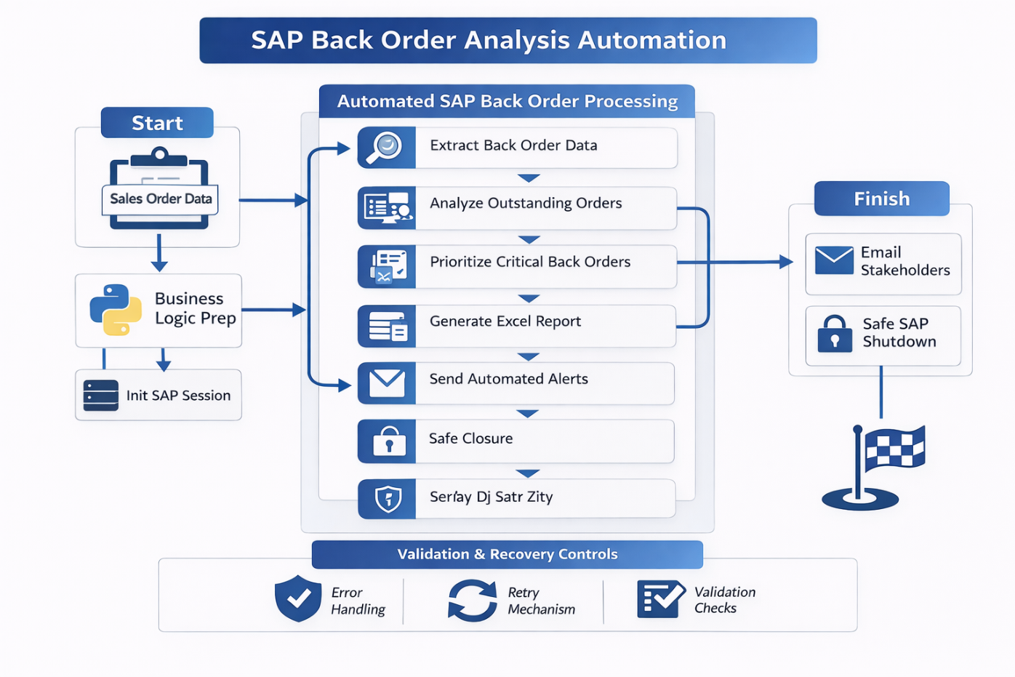

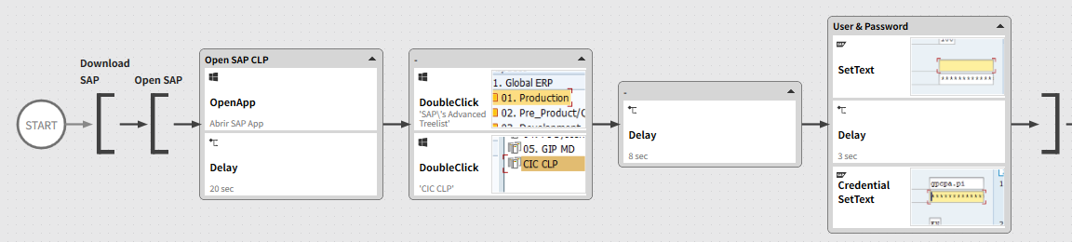
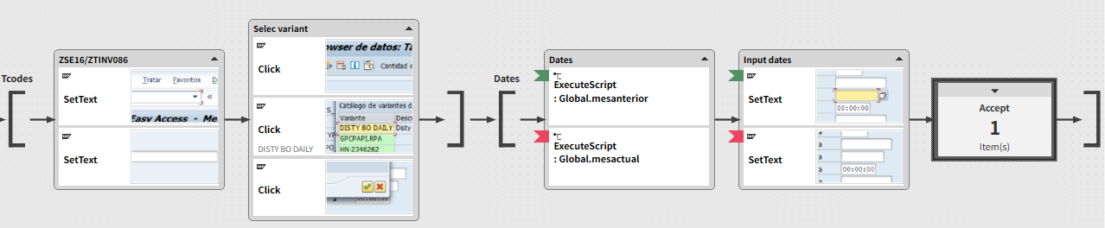
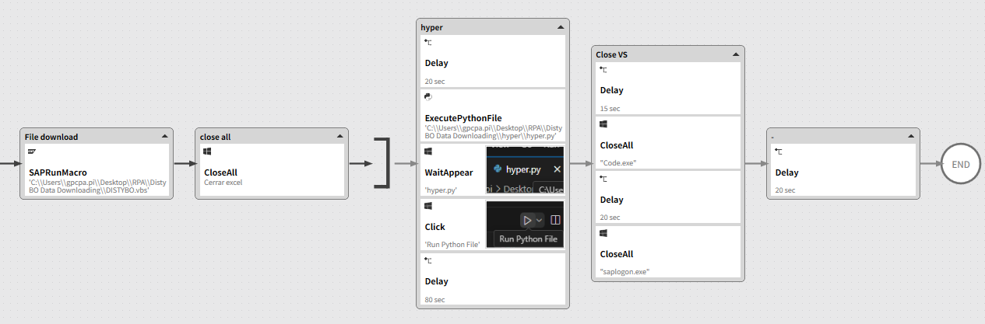

🚀 Executive Summary
Enterprise-grade RPA solution that automates the identification, analysis, and reporting of SAP Back Orders, replacing a manual, fragmented process with a validated, repeatable, and auditable automation.
The solution improves visibility over unmet demand, supports decision-making, and reduces operational workload while ensuring consistent follow-up on critical orders.

🎯 Business Problem
The Back Orders process was handled manually and presented several challenges:
- Manual SAP navigation across multiple transactions
- Limited visibility of pending and partially fulfilled orders
- High dependency on user expertise to interpret data
- Manual Excel consolidation
- Delayed reaction to supply or allocation issues
This resulted in slow response times, poor prioritization, and increased operational risk.

🧠 Solution Overview
A robust RPA solution was designed to automate the full Back Orders lifecycle:
from SAP data extraction and validation to structured Excel reporting and automated notifications.
The automation enforces business rules, ensures data accuracy, and delivers actionable insights to stakeholders.

🖼 RPA Orchestration Breakdown
- Initialization & Configuration
  - SAP session cleanup and controlled startup
  - Load execution parameters and business rules
- Back Order Data Extraction
  - Navigate to SAP Back Order / Sales Order transactions
  - Extract open, partial, and blocked orders
  - Validate data presence and consistency
- Business Logic Processing
  - Identify true back orders vs normal open orders
  - Apply prioritization rules (dates, customers, materials)
  - Flag critical or overdue items
- Report Generation
  - Create standardized Excel report
  - Structured columns for analysis and follow-up
- Notification & Distribution
  - Automated email delivery with report attached
  - Dynamic messaging based on results
- Safe Closure
  - Controlled SAP shutdown
  - Execution logging

📊 Results & Business Impact
- Faster identification of back orders
- Improved order prioritization
- Reduced manual analysis effort
- Increased visibility for supply and sales teams
- More proactive operational decision-making

🔍 Before vs After
Before
- Manual SAP queries
- Dispersed information
- Reactive issue handling
- High analyst dependency
- No standardized reporting
After
- Automated back order detection
- Centralized, validated reports
- Proactive follow-up
- Consistent execution
- Measurable efficiency gains

🧩 Key Features
- Automated SAP Back Order analysis
- Business-rule-driven prioritization
- Excel-based structured reporting
- Automated stakeholder notifications
- Validation and recovery mechanisms
- Enterprise-safe SAP handling

🛠 Tech Stack
- SAP GUI Scripting
- Python (data processing, rules, reporting)
- RPA Orchestration Platform
- Excel automation
- Email automation (enterprise SMTP)

🧠 Challenges & Design Decisions
- Data fragmentation in SAP → Solved with controlled navigation and validation
- Ambiguity between open vs back orders → Clear business-rule definitions
- Manual prioritization risk → Automated classification logic
- Stability concerns → Defensive SAP handling and session control

👤 My Role
- RPA Solution Architect
- Designed end-to-end Back Orders automation
- Defined business rules and prioritization logic
- Implemented SAP GUI automation and validations
- Built reporting and notification mechanisms

🚀 Why This Project Matters
This project shows how RPA can transform operational data into actionable intelligence, enabling faster decisions, better customer service, and reduced risk in supply and order management.

